**PROJECT REPORT TEMPLATE**

Subscribers Galore: Exploring World Top Youtube Channels

**1. INTRODUCTION**

**1.1 Overview**

A subscriber to a channel on the video-sharing YouTube is a user who has chosen to receive the channel's content by clicking on that channel's "Subscribe" button, and each user's subscription feed consists of videos published by channels to which the user is subscribed. The ability to subscribe to users was introduced in October 2005. YouTube began publishing a list of its most- subscribed channels in April 2006. An early archive of the list dates to May 2006.

1.2 Purpose

The following table lists the 50 most-subscribed YouTube channels, as well as the primary language and content category of each channel. The channels are ordered by number of subscribers; those whose displayed subscriber counts are identical are listed so that the channel whose current growth rate indicates that its displayed subscriber count will exceed that of the other channel is listed first.

**2.Problem definition & design thinking**

2.1 Empathy map

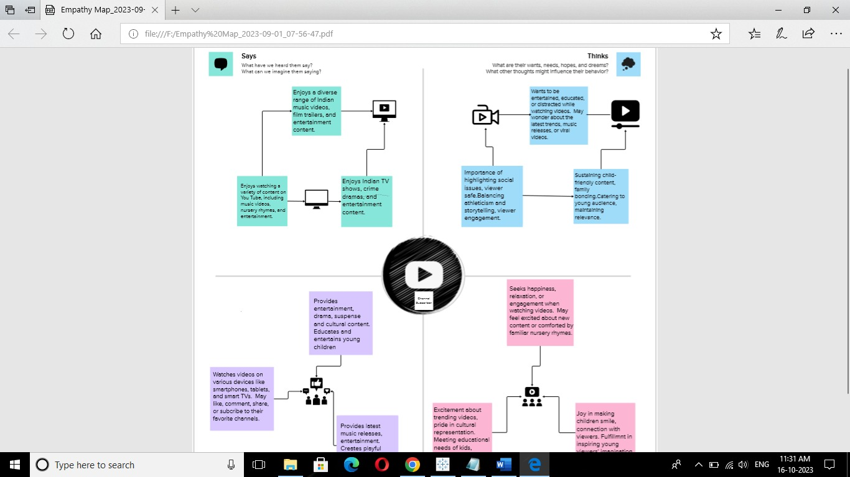

2.2 Brain stroming



3.RESULT

DASHBOARD 1

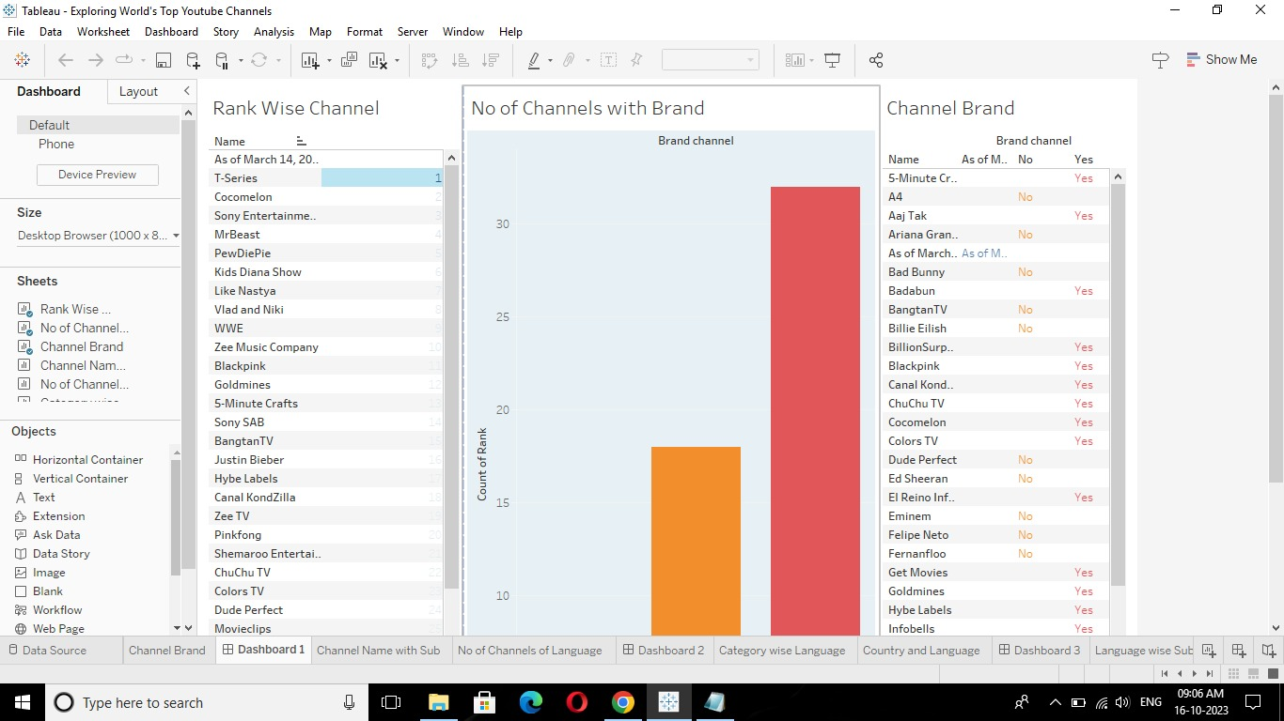

DASHBOARD 2

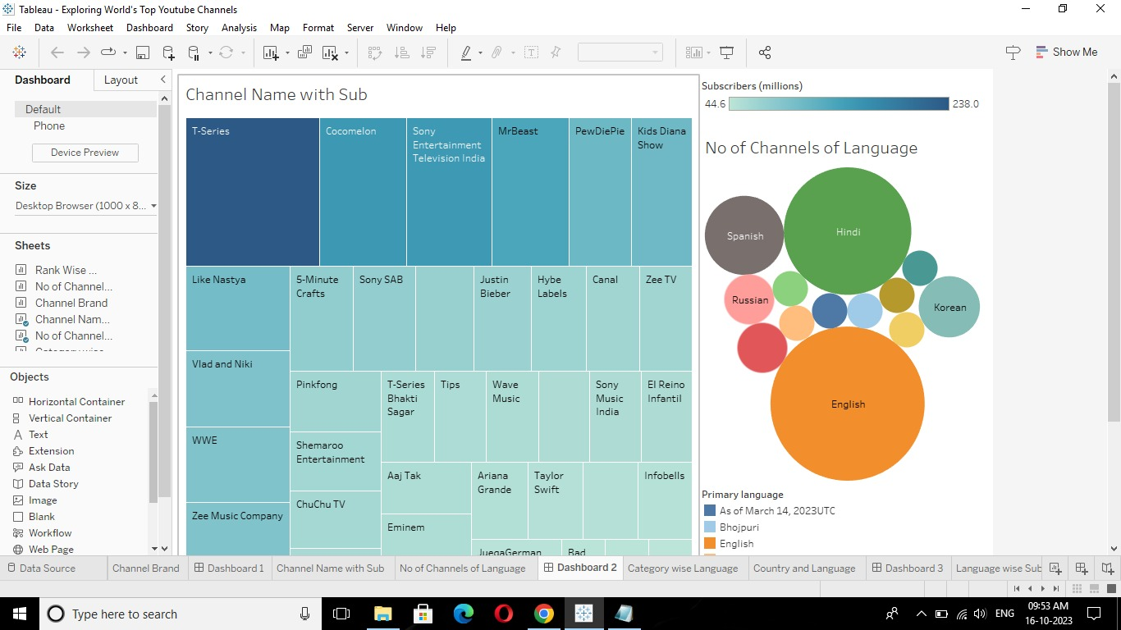

DASHBOARD 3

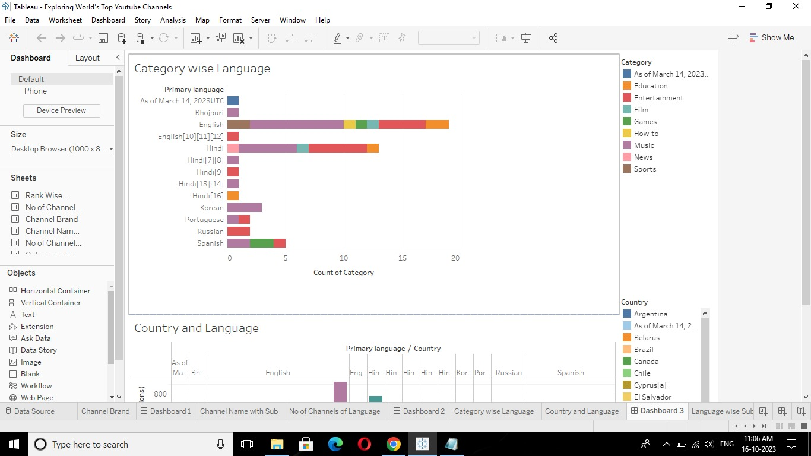

DASHBOARD 4

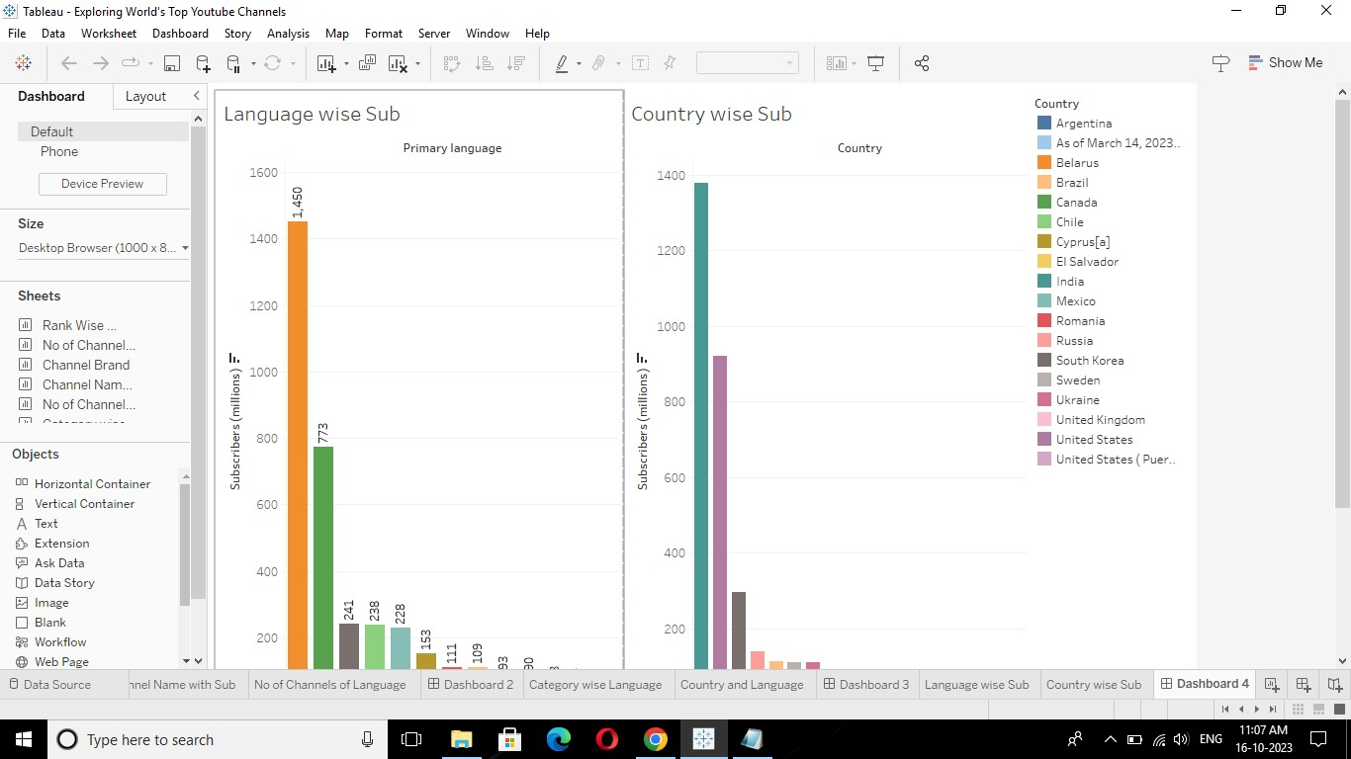

STORY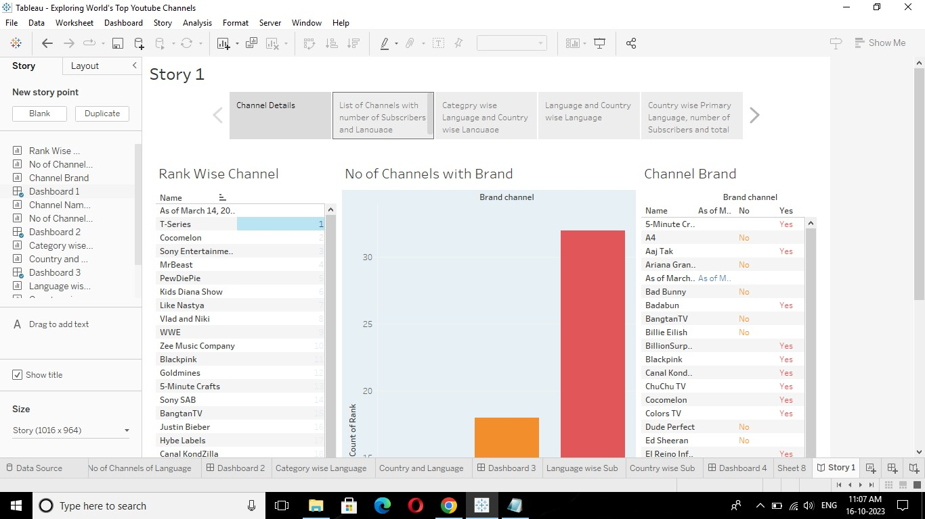

4.ADVANTAGES & DISADVANTAGES

4.1 ADVANTAGES

It’s free to use: You can watch and upload videos on YouTube. However, to get the free services, now, you have to manage several advertisements, most of which can skip, but some of which need to play partially or wholly. YouTube Premium is a paid service that allows users to go ad-free.

Wide selection of content: There is a wide variety of content available on YouTube, including music videos, educational videos, movie trailers, and more, as we have mentioned above. The range is such that people have made entire careers by being YouTube content creators in several niches.

4.2 DISADVANTAGES

Quality and Copyright: The quality of videos on YouTube can vary significantly as not all videos create professionally, and some are pirated from other places and uploaded to YouTube.

Misinformation: Some videos on YouTube contain misinformation or false information. Fact-checking information you find online, including those on YouTube, is essential. Taking the lead from personal vlogs can be exceptionally dangerous as that information can be precise to the people involved and might not be the best for you as an individual.

5.APPLICATION

YouTube is a free video sharing website that makes it easy to watch online videos. You can even create and upload your own videos to share with others. Originally created in 2005, YouTube is now one of the most popular sites on the Web, with visitors watching around 6 billion hours of video every month

6. CONCLUSION

After reviewing the results from the survey, I was not really surprised with the responses that I received. Majority of the people that I surveyed are on YouTube all the time and its to watch homemade or uploaded videos. I was shocked to learn that only one person has heard of YouTube EDU. I have heard of YouTube EDU, but I have never used it. This shows that many Universities don't use YouTube EDU in their classrooms. I learned that many people believe that YouTube should be used more in classrooms. This could be because YouTube has more to offer than just uploaded videos by users. YouTube has contracts with certain networks and many educational videos are being put on YouTube everyday. I was not expecting to learn that majority of the people are on YouTube less than an hour a week. I believe this is due to students being full time students and parents working full time jobs and taking care of their kids which gives no time for them to watch YouTube videos.

7.FUTURE SCOPE

YouTube is constantly changing, and with those changes come new opportunities for content creators. Here’s what you need to know about the future of the YouTube platform so that you can stay ahead of the curve.

It’s no secret that YouTube is a powerful force in the online world. With over 1 billion users and counting, the video-sharing platform is a significant player in online advertising and content distribution. Recent reports show that YouTube accounts for 44% of online video traffic.